Word Maps
a shared understanding

In day 2 of the kick off meeting in Alicante we created word maps for “Entrepreneurship” and “Employability”. The results of thisexercise has been mapped using a wordcloud. The more frequent the word appeared in the exercise, the larger it appears in the word cloud.
Entrepreneruship:
We grouped the words according to if they were:
- Attributes
- Knowledge
- Support

Attributes = personal skills or competenciec or characteristics an entrepreneur needs


Knowledge = things an entrepreneur needs knowledge of to be sucessful


Support = services or products an entrepreneur needs to startup
From this we can see that you all identified having ideas, knowing how to do business planning and access to capital funding as the most comon needs for engtrepreneurs.
What is also interessting to note is that there were far more words provided for the personal attributes needed, and whilst Ideas was the most frequent word, innovation, initiative and communication scored highly.
The EU recently produced Entrecomp – a framework for higher education institutions to foster entrepreneurial capability. It consists of 3 interrelated and interconnected competence areas: ‘Ideas and opportunities’, ‘Resources’ and ‘Into action’. Each of the areas is made up of 5 competences, which, together, constitute the building blocks of entrepreneurship as a competence. The framework develops the 15 competences along an 8-level progression model and proposes a comprehensive list of 442 learning outcomes. The framework can be used as a basis for the development of curricula and learning activities fostering entrepreneurship as a competence. Also, it can be used for the definition of parameters to assess learners’ and citizens’ entrepreneurial competences.
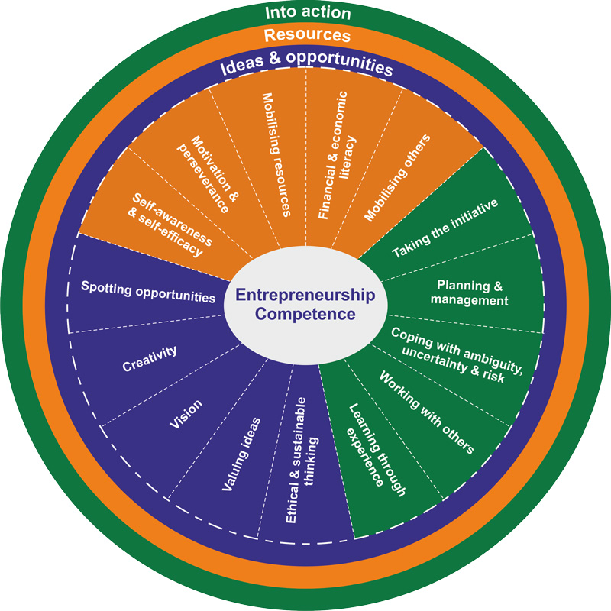

As you can see, many of the words you identified in the attributes section of the word cloud have a good fit with the Entrecomp Framework. The full document then further breaks down these definitions:
Areas | Competency | Hints | Descriptors
1. Ideas and opportunities | 1.1 Spotting opportunities | Use your imagination and abilities to identify opportunities for creating value | - Identify and seize opportunities to create value by exploring the social, cultural and economic landscape  - Identify needs and challenges that need to be met ·  - Establish new connections and bring together scattered elements of the landscape to create opportunities to create value
1. Ideas and opportunities | 1.2 Creativity | Develop creative and purposeful ideas | - Develop several ideas and opportunities to create value, including better solutions to existing and new challenges  - Explore and experiment with innovative approaches  - Combine knowledge and resources to achieve valuable effects
1. Ideas and opportunities | 1.3. Vision | Work towards your vision of the future | - Imagine the future  - Develop a vision to turn ideas into action  - Visualise future scenarios to help guide effort and action
1. Ideas and opportunities | 1.4 Valuing ideas | Make the most of ideas and opportunities | - Judge what value is in social, cultural and economic terms  - Recognise the potential an idea has for creating value and identify suitable ways of making the most out of it
1. Ideas and opportunities | 1.5 Ethical and sustainable thinking | Assess the consequences and impact of ideas, opportunities and actions | - Assess the consequences of ideas that bring value and the effect of entrepreneurial action on the target community, the market, society and the environment  - Reflect on how sustainable long-term social, cultural and economic goals are, and the course of action chosen  - Act responsibly
2. Resources | 2.1 Selfawareness and selfefficacy | Believe in yourself and keep developing | - Reflect on your needs, aspirations and wants in the short, medium and long term  - Identify and assess your individual and group strengths and weaknesses  - Believe in your ability to influence the course of events, despite uncertainty, setbacks and temporary failures
2. Resources | 2.2 Motivation and perseverance | Stay focused and don't give up | - Be determined to turn ideas into action and satisfy your need to achieve  - Be prepared to be patient and keep trying to achieve your long-term individual or group aims  - Be resilient under pressure, adversity, and temporary failure
2. Resources | 2.3 Mobilizing resources | Gather and manage the resources you need | - Get and manage the material, non-material and digital resources needed to turn ideas into action  - Make the most of limited resources  - Get and manage the competences needed at any stage, including technical, legal, tax and digital competences
2. Resources | 2.4 Financial and economic literacy | Develop financial and economic know how | - Estimate the cost of turning an idea into a valuecreating activity  - Plan, put in place and evaluate financial decisions over time  - Manage financing to make sure my value-creating activity can last over the long term
2. Resources | 2.5. Mobilizing others | Inspire, enthuse and get others on board | - Inspire and enthuse relevant stakeholders  - Get the support needed to achieve valuable outcomes  - Demonstrate effective communication, persuasion, negotiation and leadership
3. Into action | 3.1 Taking the initiative | Go for it | - Initiate processes that create value  - Take up challenges  - Act and work independently to achieve goals, stick to intentions and carry out planned tasks
3. Into action | 3.2 Planning and management | Prioritize, organize and follow-up | - Set long-, medium- and short-term goals  - Define priorities and action plans  - Adapt to unforeseen changes
3. Into action | 3.3 Coping with uncertainty, ambiguity and risk | Make decisions dealing with uncertainty, ambiguity and risk | - Make decisions when the result of that decision is uncertain, when the information available is partial or ambiguous, or when there is a risk of unintended outcomes  - Within the value-creating process, include structured ways of testing ideas and prototypes from the early stages, to reduce risks of failing  - Handle fast-moving situations promptly and flexibly
3. Into action | 3.4 Working with others | Team up, collaborate and network | - Work together and co-operate with others to develop ideas and turn them into action  - Network  - Solve conflicts and face up to competition positively when necessary
3. Into action | 3.5. Learning through experience | Learn by doing | - Use any initiative for value creation as a learning opportunity  - Learn with others, including peers and mentors  - Reflect and learn from both success and failure (your own and other people’s)

Employability:
We grouped the words according to if they were:
- Attributes
- Knowledge
- Support


Attributes = personal skills or competenciec or characteristics an employer looks for


Knowledge = things a student needs knowledge of to get a job


Support = services or products a student needs to get a job
From this we can see that you all identified soft skills, labour market knowledge and appropriate qualifications, and access to information about employers as the most common needs for graduates seeking employment.
There is some incongruity in these results. Soft skills were ranked as significantly more important than anything else and yet skill spreparation was low in identifying support needs. However there is a good match between the need for labour market knowledge and services with employer information.
A survey of Top UK employers including Seimens, AstraZeneca and BP cited their following top 10 employability skills as:
1. Communication and interpersonal skills
2. Problem solving skills
3. Using your initiative and being self-motivated
4. Working under pressure and to deadlines
5. Organisational skills
6. Team working
7. Ability to learn and adapt
8. Numeracy
9. Valuing diversity and difference
10. Negotiation skills
The UK Higher Eduication Academy (HEA) has designed an employability framework, which is alogned to the UK Professional Standards Framework, to offer a structure and process for defining and developing effective approaches to embedding employability in higher education.

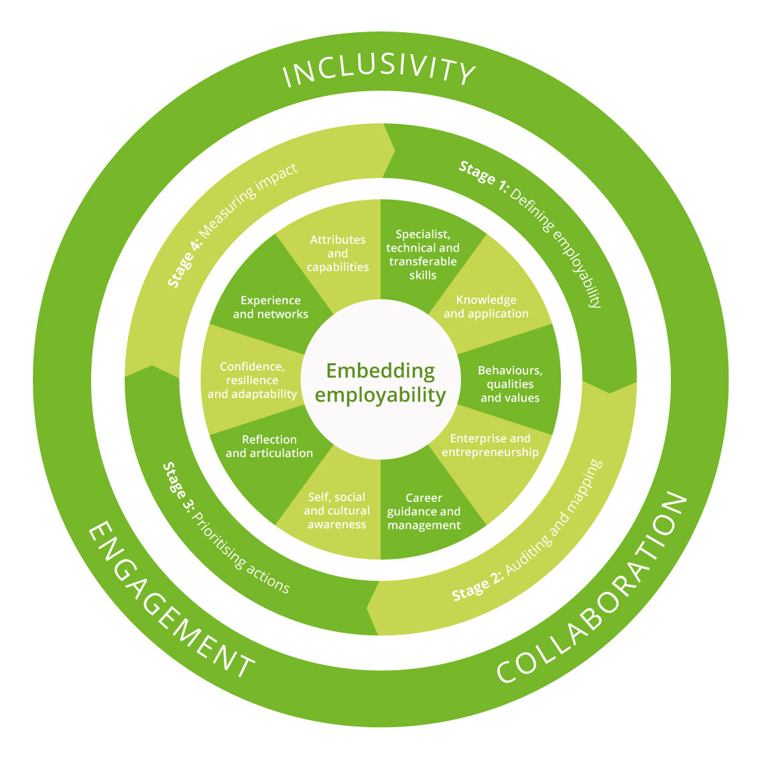

A full copy can be found here https://ec.europa.eu/jrc/en/publication/eur-scientific-and-technical-research-reports/entrecomp-entrepreneurship-competence-framework

